Binomial Test

11/11/2021 20:50

# Abstract

Outcome variable: *SPORT*  
Null hypothesis: *Pr( SPORT=0 ) = 0.5*  
Alternative hypothesis: *two.sided*

### Binomial Test

Binomial Test compares the population proportion of success (or a level of a binary variable) to a hypothesized value.

# Descriptive Statistics

Table 1 gives the basic information of the analyzing data set. Observations with missing values are removed when calculating. It shows that there is (are) 15 incomplete observation(s) in the data, and we deleted these record(s) from the data.

$Table 1.$ Completeness of Data.

|  |  |  |
| --- | --- | --- |
|  | Observation | Incomplete Observation (not used) |
| Number | 105 | 15 |

The pie chart of *SPORT* is given in Figure 1.

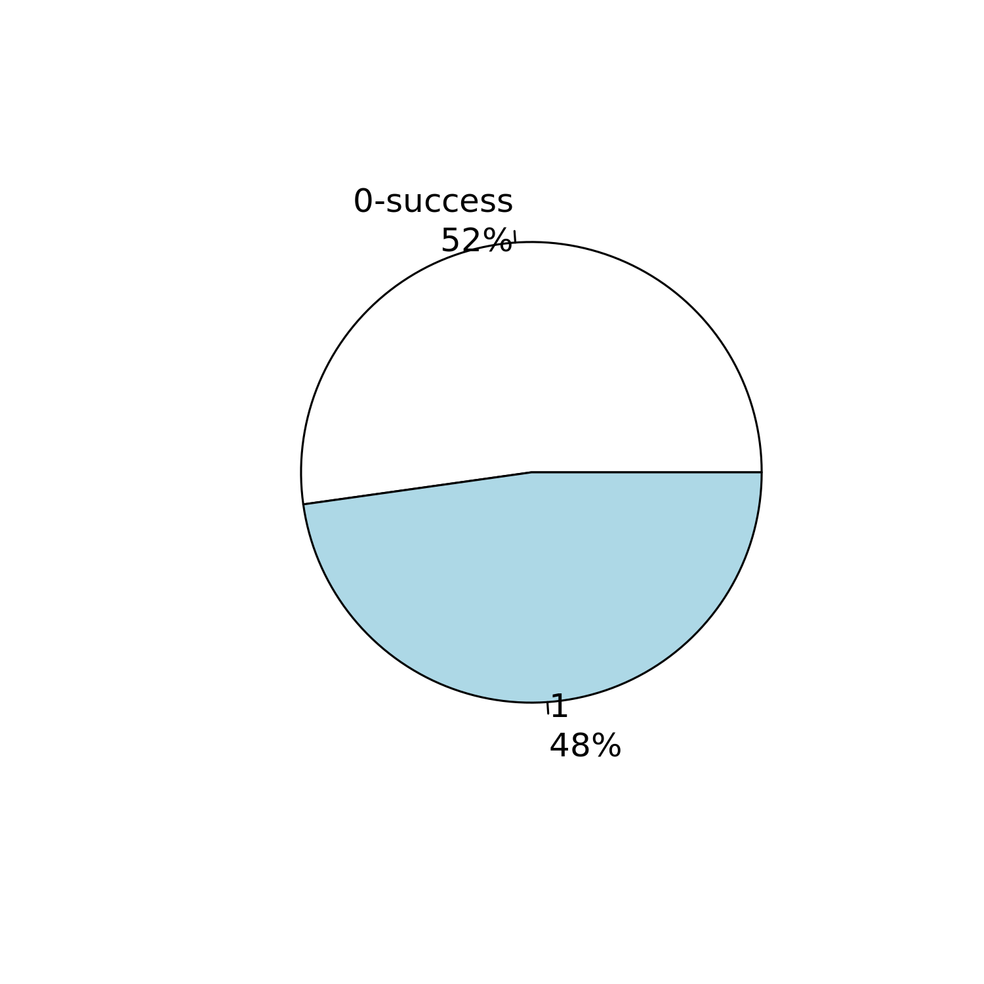

$Figure 1.$ Pie chart for *SPORT*.

The detailed frequencies of *SPORT* are given in Table 2.

$Table 2.$ Frequencies of SPORT.

|  |  |  |
| --- | --- | --- |
| SPORT=0 | SPORT=1 | NA’s |
| 47 | 43 | 15 |

# Results

The null hypothesis of the binomial test is that the success probability, the probability that *0* of *SPORT* occurs, is equal to 0.5. In addition, the alternative hypothesis is the success probability is not equal to 0.5.

A binomial test with a two-sided alternative hypothesis is employed. Table 3 gives the result of the binomial test (Clopper and Pearson 1934; Conover and Conover 1980; Hollander and Wolfe 1973).

$Table 3.$ Result of Binomial Test.

|  |  |  |  |  |
| --- | --- | --- | --- | --- |
| Null Value | Alternative Hypothesis | No. of Successes | No. of Trails | p-value |
| 0.5 | two.sided | 47 | 90 | 0.752 |

Since *p*-value=0.752>0.05, we cannot reject the null hypothesis and conclude that the success probability, the probability that *0* of *SPORT* occurs, is equal to 0.5.

The estimated success probability of *SPORT* and its 95% confidence interval are given in Table 4. The probability that *0* of *SPORT* occurs is about 0.522.

$Table 4.$ Estimated Probability and its 95% Confidence Interval.

|  |  |  |  |
| --- | --- | --- | --- |
|  | Estimated Probability | Lower | Upper |
| SPORT=0 | 0.522 | 0.414 | 0.629 |

# Conclusions

Based on the above results, we can get the following conclusion:

* There is no significant difference between the success probability and 0.5.

# Terminologies

***Contingency table***: In statistics, a contingency table is a type of table in a matrix format that displays the frequency distribution of the categorical variables.

***Null hypothesis***: In inferential statistics, the null hypothesis is a general statement or default position that there is no relationship between two measured phenomena or no association among groups.

***Alternative hypothesis***: In statistical hypothesis testing, the alternative hypothesis and the null hypothesis are the two rival hypotheses that are compared by a statistical hypothesis test. It is usually taken to be that the observations are the result of a real effect.

***p-value***: In statistical hypothesis testing, the *p*-value is, for a given statistical model, the probability that, when the null hypothesis is true, the statistical summary would be greater than or equal to the actual observed results.

# References

Clopper, Charles J, and Egon S Pearson. 1934. “The Use of Confidence or Fiducial Limits Illustrated in the Case of the Binomial.” *Biometrika* 26 (4): 404–13.

Conover, William Jay, and William Jay Conover. 1980. “Practical Nonparametric Statistics.”

Hollander, Myles, and Douglas A Wolfe. 1973. *Nonparametric Statistical Methods*. Wiley New York, NY, USA.